Problem 2 - Greenhouse
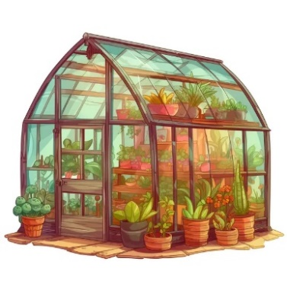
Owning a greenhouse must be challenging. You have to deal with many tasks like following the steps necessary for the crops to grow.
On the first line, you will receive the crops, separated by " & ".
On the next lines, until you receive "Collect!", you will be receiving commands as follows:
- "Plant {crop}":
  - If the crop is not in the collection, plant it (add it) at the beginning of the sequence.
  - Otherwise, ignore the command.
- "Transplant {crop}":
  - If the crop is in the collection, transplant it (move it) to the end of the sequence.
  - Otherwise, ignore the command.
- "Replace {cropIndex₁} {cropIndex₂}":
  - If both crop indexes are valid, swap the crops' places.
  - Otherwise, ignore the command.
- "Uproot {crop}":
  - If the crop is in the collection, uproot it (remove it).
  - Otherwise, ignore the command.
In the end, upon receiving a command "Collect!", print the final state of the greenhouse collection with each crop, separated by " | ".

Input / Constraints
- On the first line, you will receive the crops, separated by " & ". There will always be at least two different crops initially.
- On the following lines, you will receive commands until the command "Collect!".
- All the commands will be valid.

Output
- Print the crops in the final collection on a single line, separated by " | " (if there is more than one crop).
- There will always be at least one crop to print at the end.

Examples
Input | Output
tomato & carrot & potato  Plant cucumber  Transplant carrot  Replace 1 3  Collect! | cucumber | carrot | potato | tomato
Comments
The initial state of the sequence is "tomato", "carrot", "potato".
The first command is "Plant cucumber": "cucumber" is not in the collection, so it is added at the beginning of the sequence.
The new state is "cucumber", "tomato", "carrot", "potato".
А new command is received "Transplant carrot": "carrot" exists, so it is moved to the end of the sequence.
The new state is "cucumber", "tomato", "potato", "carrot".
A command "Replace 1 3" is received: both indexes 1 and 3 are valid, so we swap the crops at these positions (index 1 has "tomato" and index 3 has "carrot", now swap them).
New state: "cucumber", "carrot", "potato", "tomato".
Command: "Collect!" comes: the program ends, and the final collection is printed.
The output is "cucumber | carrot | potato | tomato"
Input | Output
mint & basil & pea & pepper  Plant bean  Replace 3 5  Replace 1 2  Uproot basil  Collect! | bean | mint | pea | pepper
tomato & bean & pea  Uproot tomato  Uproot bean  Collect! | pea

